Model Optimization and Tuning Phase Template

Date | July 2024
Team ID | 740053
Project Title | Estimating the stock keeping units using Machine Learning
Maximum Marks | 10 Marks

Model Optimization and Tuning Phase
The Model Optimization and Tuning Phase involves refining neural network models for peak performance. It includes optimized model code, fine-tuning hyperparameters, comparing performance metrics, and justifying the final model selection for enhanced predictive accuracy and efficiency.

Hyperparameter Tuning Documentation (8 Marks):
Model | Tuned Hyperparameters
Linear Regression | #importing the library for grid search  from sklearn.model_selection import GridSearchCV  The ‘lr_param_grid’ specifies different values for regularization strength (C), solvers (solver), and penalty types (penalty). GridSearchCV (lr_cv) is employed with 5-fold cross-validation (cv=5), evaluating model performance based on accuracy (scoring="r2 score").  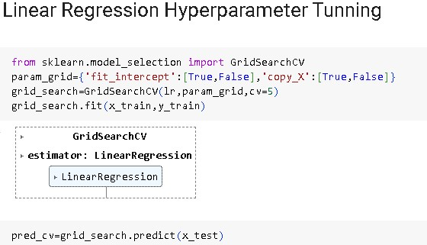
Random Forest | The parameter grid (make_regression) for hyperparameter tuning. It specifies different values for the number of trees (n_estimators), splitting criterion (criterion), maximum depth of trees (max_depth), and maximum number of features considered for splitting (max_features). GridSearchCV (rfc_cv) is employed with 3-fold cross-validation (cv=3), evaluating model performance based on accuracy (scoring="r2 score").  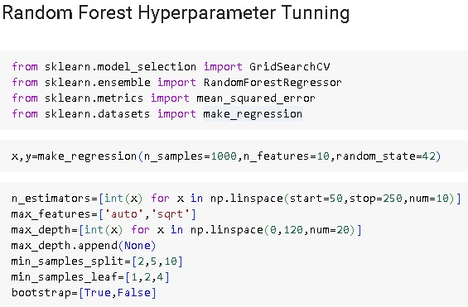
Decision Tree | The parameters (params) define a randomized search for hyperparameter tuning of the Decision Tree Regressor (DecisionTreeRegressor), including max_depth, min_samples_leaf, min_samples_split and max_features . RandomizedSearchCV is used to evaluating model performance based on r2 score(scoring="r2 score")  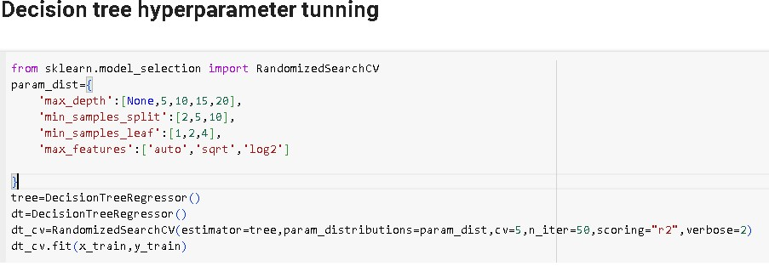

Final Model Selection Justification (2 Marks):
Final Model | Reasoning
Random Forest | Random Forest model is chosen for its robustness in handling complex datasets and its ability to mitigate overfitting while providing high predictive r2 score.  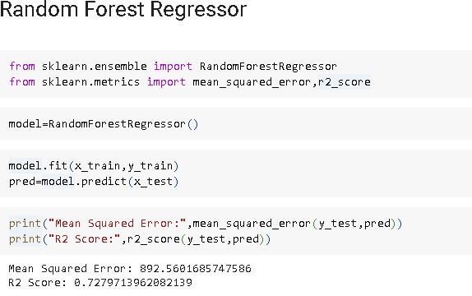  Above all the models Random Forest model have the highest r2 score among all the models.  A higher r2 score is generally considered better as it indicates a more accurate and reliable model.

